Booking Management System

**Version:** v2.2.0  
**Release Date**: 1st July, 2025.

**Prepared by:** Wechuli Godwin.

This release marks a significant milestone with major enhancements in tracing, alert creation, code organization, and performance. It introduces improved user experience, better code management, and backend-driven functionality.

### New features

## Shift to Controller Logic

Moved key logic for rescheduling from JavaScript to Laravel controller methods.

Improved code separation and maintainability.

1. Tracing Feature Added  
   A new tracing system has been implemented with color-coded rows to visually indicate statuses such as: Contacted and not contacted.

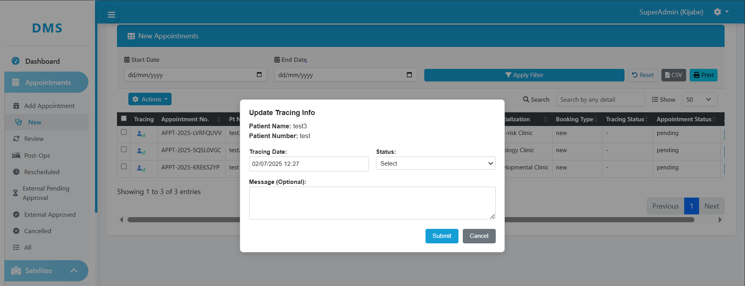

**Screenshot 1:** Tracing Pop-up Interface

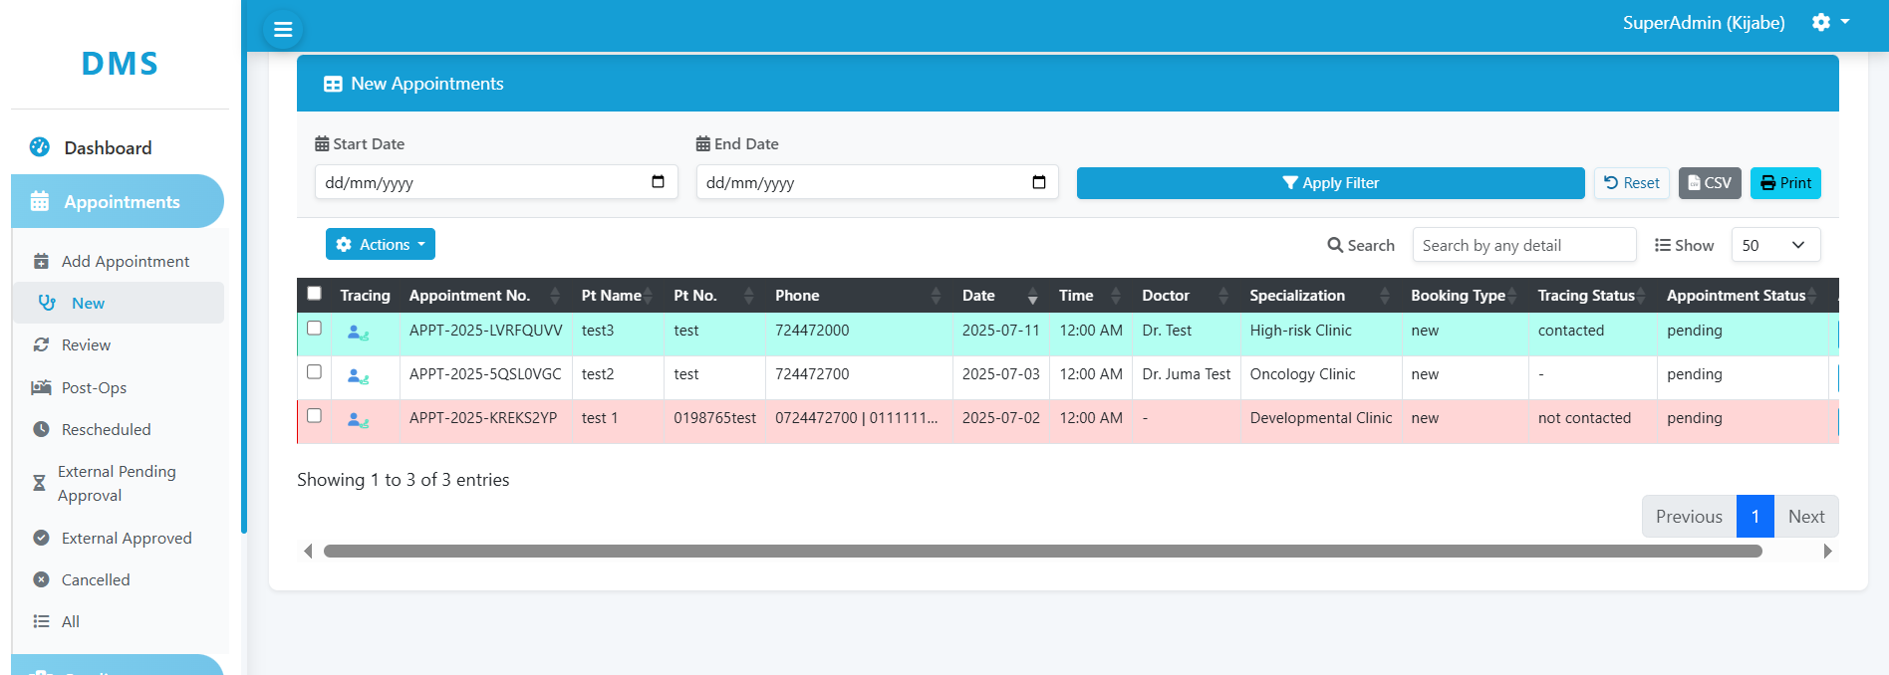

**Screenshot 2:** Table View Showing Contacted and Not Contacted Rows

## Messaging (Alerts) System

Ability to create alerts for both existing and non-existing appointments.

Streamlined alert creation through structured modals.

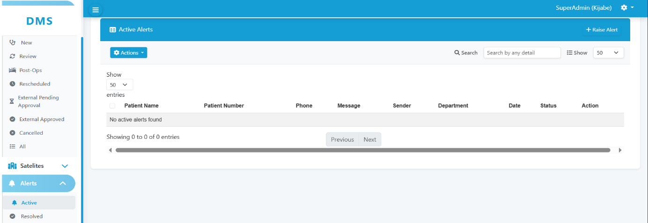

**Screenshot 3:** Alerts Listing Page (Active alerts)

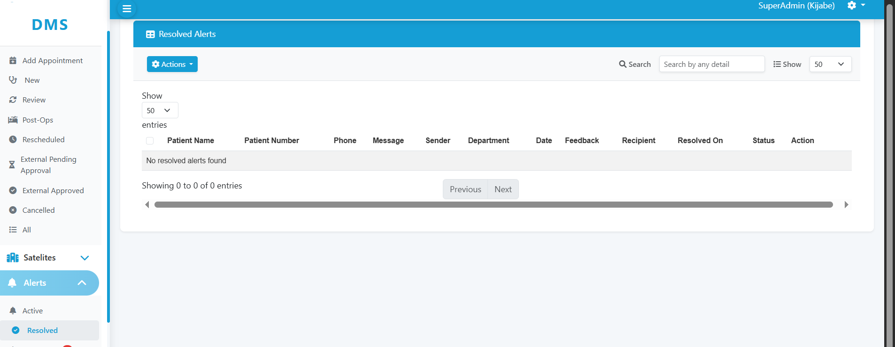

**Screenshot 4:** Alerts Listing Page (Resolved alerts)

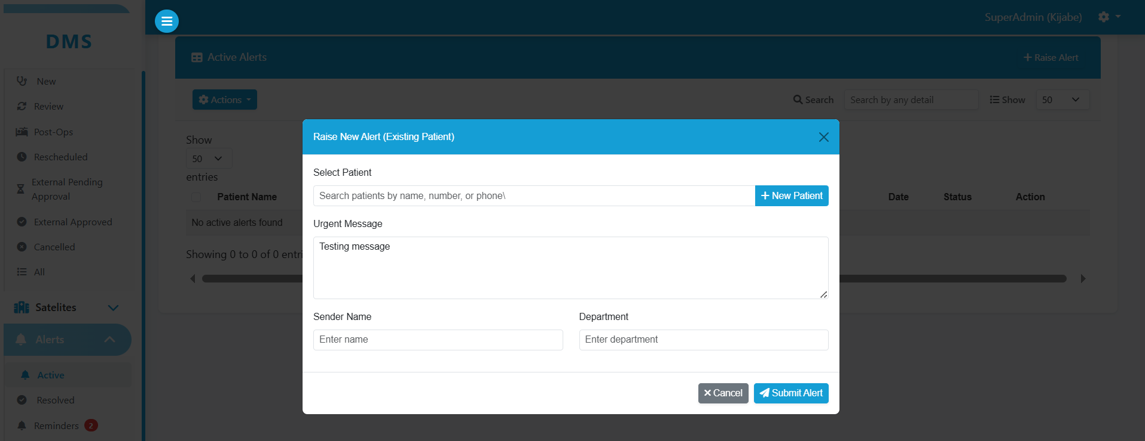

**Screenshot 5:** Alert Creation Modal for Existing Patients

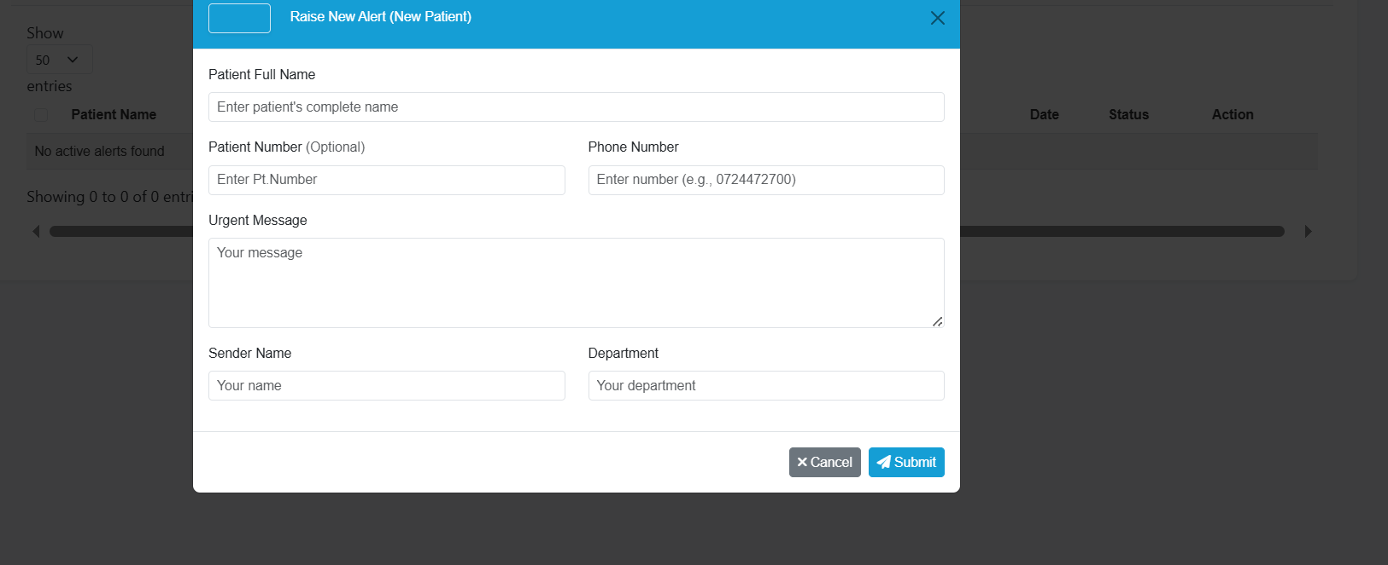

**Screenshot 6:** Alert Creation Modal for New Patients

### Improvements

1. Optimized Page Loading  
   Faster transitions and page loads after viewing and editing details, resolving and reopening alerts and also after tracing an appointment.

## Code Refactoring

Cleaner, more modular code

Easier to debug and maintain.

## Data Handling & UI Enhancements

* The system now automatically filters records for the current month, while also allowing users to choose a custom date range.
* Alerts, feedback, and bulk operations handled via AJAX controller endpoints.
* Integrated server-side Data Tables for better performance.
* Bootstrap 5 UI enhancements for modals, buttons, and table formatting.